AOD 2022 Successful Recital Guide

The recital gives each of our students the chance to “take the stage” and show their family and friends the result of all their hard work this past season. Each show is treated as a professional performance with sound, lighting, and stage crews. We know that the recital can be a very hectic time for everyone and so we hope this guide will allow things to run as smoothly as possible. Please read this guide thoroughly and all the way through as it contains all the information you will need to make this year’s recital experience successful. I cannot stress enough how important it is to read this in its entirety!
We are very excited to bring “Viva Las Vegas” to the stage June 17-18 and appreciate your help and dedication in making it the best it can be. As always, if you have any questions or concerns, please feel free to call or email us.
Shows: We will be producing a total of 4 shows. The shows are listed below by day and time and which classes are performing in that show.
Friday June 17th 6:00pm Show
Adv. III B
Adv. III A
Adv. II
Adv. I
Adv. Acro
Intermediate Level I
Intermediate Level II
Int. Acro

Saturday June 18th 11:00am Show
Combo I, II and III Classes
4-6 Hip-Hop
7-8 Classes
7-9 Classes
9+ Classes
10+ Classes
Beginner Acro
Miracles In Motion
Diamond, Sapphire & Emerald teams

Saturday June 18th 2:00pm Show
Adv. III B
Adv. III A
Adv. II
Adv. I
Adv. Acro
Intermediate Level I
Intermediate Level II
Int. Acro
Saturday June 18th 7:00pm Show
Adv. III B
Adv. III A
Adv. II
Adv. I
Adv. Acro
Ruby Team and Tiny Gems

Tickets:
- Tickets will go on sale picture week, Monday May 16th – Thursday May19 ^{th} 3:00pm-8:00pm
- Cost: $20.00
- Assigned seating. No limits
- Sales are first come first served. When you come in you will view the seating charts and pick your seats. You will receive your tickets at that time.
- Graduating Seniors will have first choice of seating on Friday May 13th 4:00-7:00pm. After this date I cannot guarantee any seats. If you cannot make it in that day, please send someone in for you.
- TICKETS ARE NON-REFUNDABLE!!! PLEASE BE AWARE OF THIS WHEN YOU PURCHASE!
- Tickets will continue to be on sale in our office up through dress rehearsal week and you can still purchase tickets during dress rehearsal and at the door, if there are still seats left.
- You cannot purchase tickets, if you have an outstanding balance on your account.
Recital T-Shirts: Recital t-shirts will have all dancer’s names listed on the back. I have attached the list of names. IF THERE IS A SPELLING ERROR, YOU NEED TO NOTIFY THE OFFICE IMMEDIATELY!!! T-shirts will go on sale the week of picture week and are $18.00 each and 20.00 for sizes XXL-XXXL

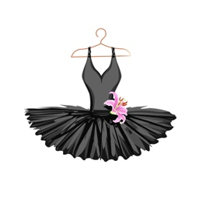
Costumes: Costume companies are doing their very best to get us our costumes in time for picture week. The supply chain and shipping issues have caused major delays. As costumes arrive, they will be handed out to students, however, please be aware that some may not get here until right before pictures. We ask for your patience and understanding. Costumes will not be handed out to any student that has an outstanding balance. Once you receive your costumes, they need to come out of their bags and be hung up. Tutus should be hung upside down in order for it to release any wrinkles and become full. Costumes CAN NOT BE IRONED! Steamers are fine BUT be super careful. Costumes are not custom made so some alterations will probably be needed. Please do not allow children to wear their costumes until picture day and recital. If something should happen to your child’s costume, we cannot get another one. All alterations to costumes need to be done prior to picture day. This includes sewing straps and additional pieces onto the costume. Please put your child’s name in everything including, tights, shoes, costumes and bags. Costume accessories such as gloves and hair pieces are easy to lose, so be sure to keep them together in a small zip lock bag with your child’s name on it. If you have several costumes, it is a good suggestion to buy some garment bags and keep each costume with its accessories, tights and shoes in a separate bag. This will keep things organized for all shows and make any quick changes a breeze for you. Make sure shoes are cleaned up and in good condition.
No underwear (tights act as underwear). No jewelry (except AOD rhinestone performance earrings which can be purchased in the studio boutique), No colored nail polish is to be worn on hands or feet. Workshop classes need to remove any bows from tap shoes and replace it with black elastic, so shoes do not come untied on stage. You can get this elastic at Walmart, Hobby Lobby, etc.
Shoes and Tights: TIGHTS MUST BE CAPEZIO BRAND TIGHTS!!!! NO OTHER TIGHTS ARE PERMITTED! Tights may be ordered in our boutique. PLEASE DO NOT WAIT TO PURCHASE TIGHTS! With all these shipping delays, it is taking double the time to come in. Jazz shoes and hip-hop shoes must also be purchased through AOD. You cannot get these shoes in any store. * Fishnet tights are Balera brand.
Recital Hair:

All students Must have their hair parted in the middle, slicked back and pulled in a tight low bun. Everyone MUST USE A HAIRNET! This will keep the bun in place for the entire performance No Bangs or flyways! We will be posting a tutorial video on our website next week. There is a picture below.
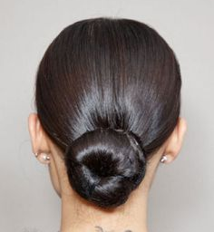

Recital Make-up: Makeup should be heavy, and everyone needs to wear base and powder to set it. Eyes should be done in 2 shades of brown (darker shade in corner and crease) with white highlighting the brow, heavy eyeliner and mascara. Blush should be heavy and applied directly under the cheek bone. EVERYONE must wear a burgundy lipstick. We recommend MaryK Crush Berry with Evening Berry Lip Gloss over it. Remember the lights will make you look very pale and washed out, so make sure you have enough makeup on. If makeup looks beautiful up close, it probably isn’t enough. False eyelashes are optional but highly recommended for older students. Again, if you go to our website there is a tutorial on how to apply stage makeup. www.artofdancestudios.com We also have Mary K samples in the office of recommended colors. Also, Miss Jenna is our Mary K representative and can help you with of those products you may
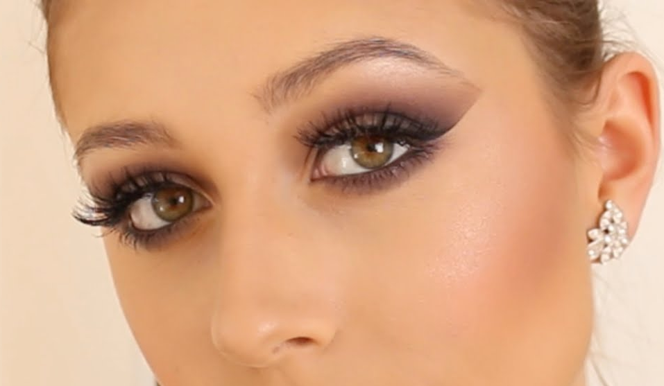

Recital Day: Please make sure you are aware of what show your child is performing in. All dancers need to report 1 hour prior to show time. We need to take attendance and make sure everyone is present. Dancers should arrive with hair and makeup done. Please make sure you eat something prior to coming to the show. Remember no one will be allowed backstage or in dressing rooms once the show starts! We have staff that will be in the dressing rooms with your children. Bring your child to their assigned dressing room 1 hour prior to show. Thirty minutes prior to the show, you will be asked to leave the dressing room and take your seat in the audience. We will have staff and senior dancers helping with your children. Once your child has danced, you are free to go. We hope you stay for the entire show but if you can’t, you may go to your child’s dressing room, see the head person in charge, they will have you sign your child out and you are free to go. All dancers that stay for the entire show, will come back out after finale for a final bow. After the show, dancers will be escorted back to their dressing rooms for pick up.
Frequently asked questions:

- Do I need to Purchase a ticket for my 3 year old? Yes, children 3 and up need to purchase a ticket. Any child under 3 is free but must sit on your lap, unless a seat next to you is open.
- How do I know what shoes and tights my child needs? We emailed out costume sheets for you child back in February that lists all tights and shoes needed.

- Is Dress Rehearsal mandatory? Yes, dress rehearsal is mandatory. This is the only chance your child will have to practice their dance, finalize spacing and make corrections on the stage before the big show.

- How will my Combo III dancer change her tights? Combo III dancers will layer their tights. They will put their pink ballet tights over their tan tights. When they are done their ballet dance, the backstage moms will just help them remove their pink tights and put their next costume on. This way your child never has to completely remove their tights.

- How long are the shows?
*Our Friday 6:00, Sat 2:00 and 7:00 shows will run approximately 2.5 hours
*Our Saturday 11:00am show will run approximately 1.5 hours.
5. Can I take pictures and video at the recital and dress rehearsal? NO! Pictures and videotaping is strictly prohibited! If you are seen taking video or pictures, you will be asked to leave the theatre.
6. Can I come back to the dressing room to help my child change? No, parents are not allowed backstage or in the dressing rooms at any time during the performance. We have backstage moms, alumni, staff, and our senior students there to assist our children. Enjoy the show and let us take care of it.
7. Does my child need to stay for the entire performance? We would hope that everyone would stay and enjoy the entire show, but we do understand, if you need to leave. In that case, please come to your child’s dressing room and see the mom in charge. She will give you a sheet to sign your child out early.
8. Can I take my child into the audience to watch the rest of the show, once they are done dancing? We prefer not to disrupt the show for others by people moving in and out, but if you really want to, you can change your child into street clothes (they will not be allowed in the audience in a costume) and they may go into the audience to watch. Please be aware that you will need to move your seat to the back or to the balcony. They do not need a ticket. Also, if you take your child, they cannot come back for final bows at the end of the show.
9. Should I send my child with a drink and snacks? Please send your child with water only to drink. If this spills it will not stain their costumes. Snacks are allowed but we ask that you keep it simple, like pretzels or crackers and absolutely NOTHING CONTAINING NUTS!
*** NO MYLAR BALLOONS ARE ALLOWED IN THE BUILDING!!!! THEY SET OFF THE FIRE ALARM. IF YOU BRING BALLOONS, YOU WILL BE ASKED TO LEAVE THEM OUTSIDE.

Recital Programs and Shout Outs: Recital programs will be digital again this year. You will simply scan the QR code on our website or on one of the posters in the lobby. The program will then pop up on your phone. We will be doing shout outs, and ads if anyone is interested. Shout Outs are due no later than May 10th. Order forms are attached.

Picture Week: Picture week is May 16th-19th during your child’s normal class times. Please keep in mind we have 4 studios in session during a 1 hour time slot, therefore please see the attached Picture Week Schedule for your child’s exact time. All pictures will be taken in studio A and we will use studio B as a changing room. The schedule is very tight and therefore, we cannot wait for anyone that is late. We will be taking group picture first the individual pictures.
All pictures will be posted online by the next day to view and order. Pictures will only remain online until July so be sure to order before then! You need to arrive with your hair and makeup done. Hair and makeup can be done however you like, but remember, they are dance pictures and photos will come out best if hair and makeup reflect that. Costumes should have all the alterations done to them prior to picture day and PLEASE make sure you are wearing the correct color tights! Once your picture has been taken, you are free to go. Please see Picture Schedule and ordering instructions attached.
Dress Rehearsal: Dress rehearsal will be held at Zoellner Art Center from June 14th -16th. One adult only is allowed to accompany your child into the theatre. A dress rehearsal schedule will be out next week. Combo classes, 4-6, 8+, 9+, & 10+ classes will only be scheduled on one of those days. You must arrive 45 minutes prior to your scheduled time in full costume and ready to dance. If you are late, we will not hold up rehearsal. I want to be very clear so there is no misunderstanding: If we are running 30 minutes ahead of schedule and you are not there, you will miss your child’s dress rehearsal. Zoellner keeps us to a tight schedule, and we cannot run behind. THIS IS A FULL DRESS REHEARSAL and therefore, your hair and makeup are to be done as well as all proper costumes, shoes and tights. Please do not show up with holes in your tights or the wrong color tights. When you arrive, please stop by the table out front and a staff member will direct you to your dressing room and let you know where you should be. We will call each group up by class, they will perform their number and the teacher will make any corrections. Once your child is done all their dances, they are free to go.

Videotaping and Photography: Our show will be professionally videotaped and photographed. Anyone seen taking videos or pictures at the recital or dress rehearsal, will be asked to leave. This rule is in place for the safety of our dancers, integrity of our choreography, and so that everyone may enjoy the show. We will be emailing media package order forms out next week.
Other Recital Guidelines: 1. Plan ahead! Don’t wait until dress rehearsal to check that you have everything. Make a packing list and double check it! 2. PUT YOUR NAME IN EVERYTHING!!!!!! 3. Stretch! Please make sure that you all take a few minutes to properly stretch. 4. Bring a water bottle and snack. 5.If you are not staying to see your child dance, please be sure you are there on time to pick them up. 6.Please go over everything in this packet with your child so they are also aware of all the rules. MOST IMPORTANTLY... HAVE FUN AND GO OUT ON THAT STAGE AND “SHINE”!
If you are new to AOD or just have some questions you would like answered personally, please feel free to call or stop in the office at any time.
Zoellner Art Center: 420 East Packer Ave. Bethlehem 18015 610-758-The parking garage is just past the flags. There is a fee to park in the garage.

